**EXAM SEATING ARRANGEMENT**

**Problem Definition:-**Building the project that provides a way to allocate and provide schematic view of exam hall for each students of various branches and sections without any clash . It also keep a check at the duties of various teachers at different classes during exams.

•The system stores list of classes , teachers and capacity of rooms and list of students appearing the exam on each day.

•The system also provides a facility of getting a chart of allotment to administrator and a email notification of allotment to every individual.

**Project Objectives:-**

• To manage the details of Exams, Seats, Students and Rooms.

•The project is totally built at administrative end and thus only the administrator is guaranteed the access.

• To reduce the manual work for managing the Exams, Seats, Students.

•To track all the details about the Students , Teachers and Rooms.

**Proposed Plan of Work:-**

The aim of proposed system is to develop a system of improved facilities. Theproposed system can improve all the limitations of the existing system. Thesystem provides proper security and reduces manual work.

•Security of data.

•Ensure data accuracy.

•Proper control of higher officials.

•Minimize manual data entry.

•Minimum time needed for various processing.

•Greater efficiency .

•User friendly and interactive.

•Minimum Time required

**Methodology:-**

* Step 1: Gather Requirements
* Step 2: Develop the Seating Layout
* Step 3: Build the Student Database
* Step 4: Design the Seating Algorithm
* Step 5: Implement Diversity and Fairness Rules
* Step 6: Optimize Space Utilization
* Step 7: Create an Administrator Interface
* Step 8: Test the System
* Step 9: Launch the System

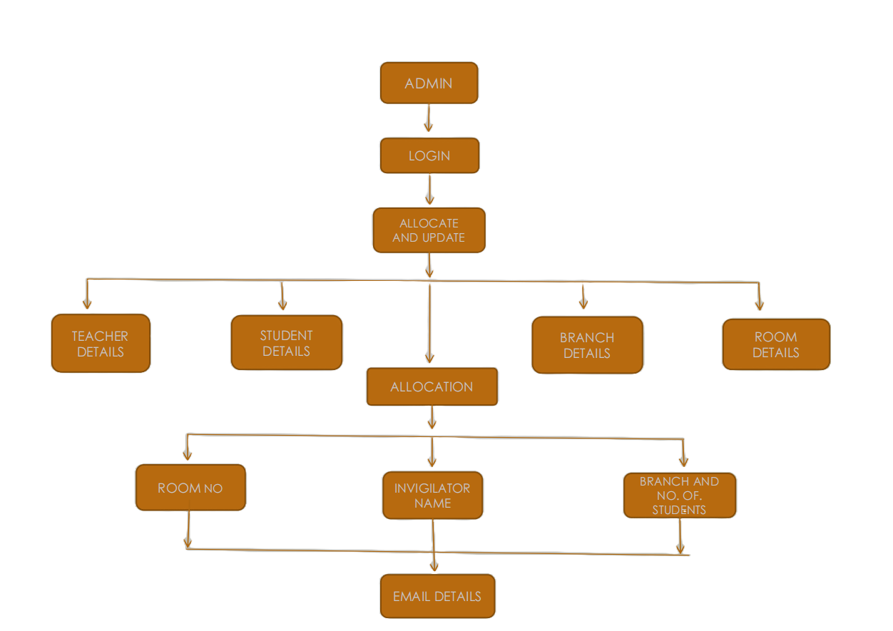

**Technology:-**

* Backend programming : React, Nodejs
* Frontend programming : CSS, JavaScript
* Database Connectivity : Java, Sql

**Functional Specifications:-**

•Provides searching facilities based on various factors such as Student , Roll number , Rooms ,Exam.

•Exam Seating Arrangement system also manages teacher details , Room allocation details for Exam.

•It tracks and manages the information of Seats.

•Editing , Updating and adding of Records is improved which results in proper resource management of Exam Data.

•It deals with monitoring information and transaction of roll numbers and also the seating rooms and pattern of various branches.

•Integration of all records of individual rooms.

•The user in the management system is the administrator that does the authentication by logging in with the respective credentials.

•Provide Schematic view of seating arrangement.

•The user has two ways to access the management system

1. Student management

2. Teacher management

**Project Scope:-**

•Our project aims at Business process automation , we have tried to computerize various process of Exam Seating Arrangement System.

•In computer system the person has to fill the various forms and number of copies of the forms can be easily generated at a time.

•In computer system , it isn’t necessary to create the manifest but we can

directly print it which is time and cost saving.

•To assist the staff in capturing the effort spent on their respective working areas.

•The system generates types of information that can be used for various purposes

•Have good interface and easy to operate

|  |  |  |
| --- | --- | --- |
| **Roll. No.** | **Name of Students** | **Name of Guide** |
| 32 | Lokendra Sinha | Dr. Nisarg Gandhewar |
| 35 | Manish Kumar Ambule |
| 45 | Raj Khatri |
| 52 | Satwik Shirpurwar |

**Approved by :**

Dr. Nisarg Gandhwar Prof. Priya Parkhi

(Guide) (Project Coordinator)